**REPORT**

**UNVEILING THE VIRTUAL CLASSROOM: AN IN-DEPTH ANALYSIS OF THE ONLINE EDUCATION SYSTEM**

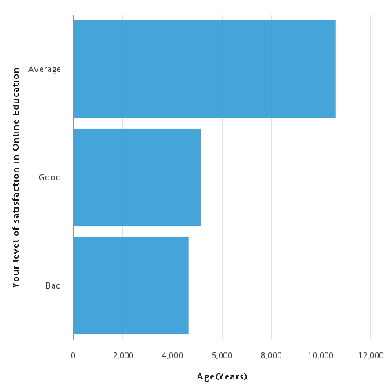Age Vs Level of satisfaction in online education

Aug 5, 2023 1 4:16:21 AM

